Customer | EEA
Project name | SC 57032  New website for the Reporting Obligations Database (ROD) - JAVA MVC Development
Document | Software Architecture and Technical Specifications

Date and version | Signature
21st of December | Javier Robles  jrobles@bilbomatica.es  Mikel Santamaria  msantamaria@bilbomatica.es

Table of contents
0 Overview of the current structure 3
1 New architecture for ROD 3.0 4
1.1 Backend module 4
1.2 Frontend module 6
1.3 RESTful APIs 6
1.4 Database 7
2 Best practices 8
3 Our development environment 10

Overview of the current structure
LINKS BETWEEN OTHER REPORTNET MODULES AND ROD

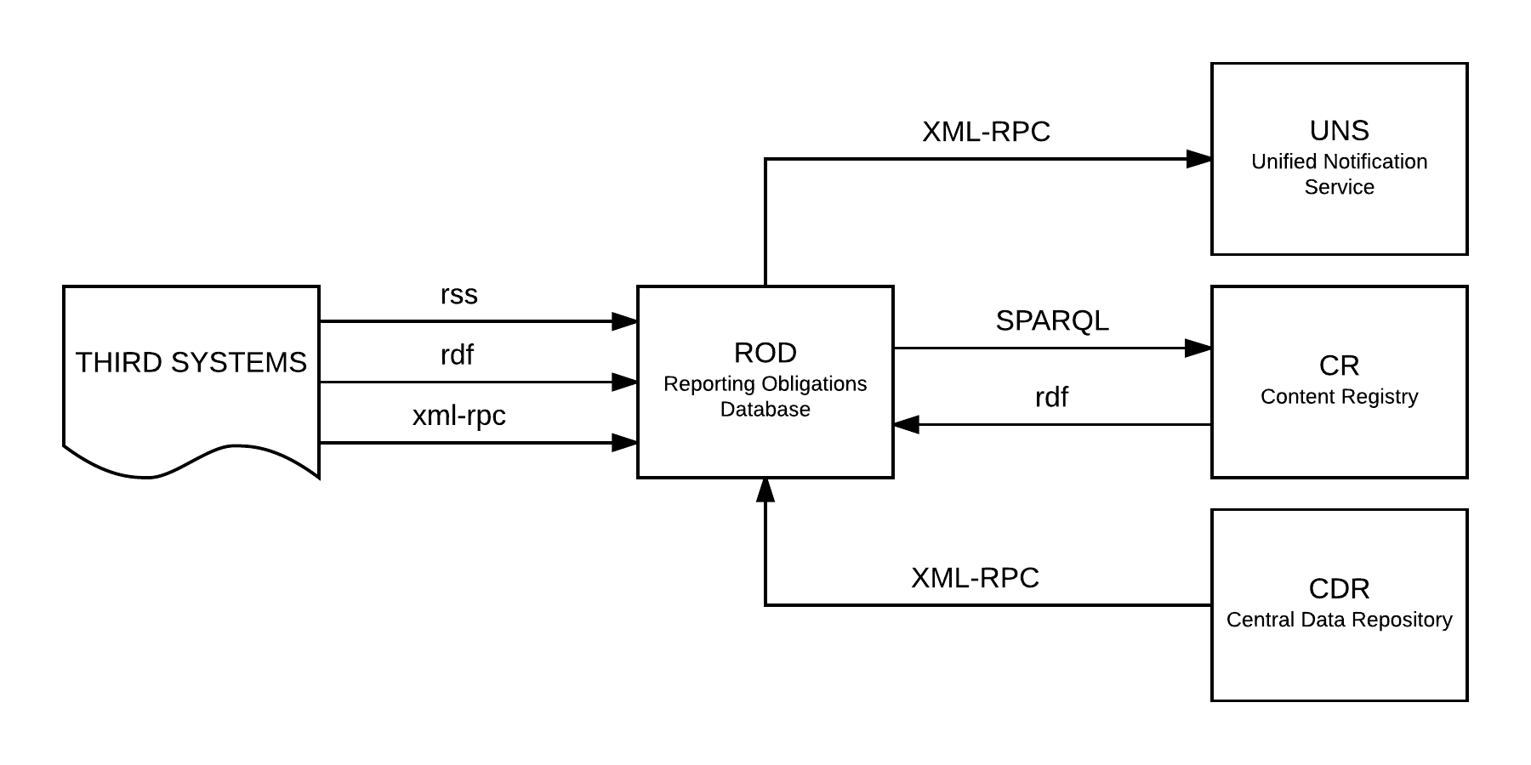

CURRENT Technical specifications

- Framework Stripes 1.5.1
- The package is built with Maven
- The user interface now uses Stripes as the templating mechanism
- The harvest and deadlinecalc scripts are now embedded in the application and scheduled with quartz.
- Changes to obligation and legal instruments are now copied to a general UNDO table, which allows the user to roll back an edit.
- Liquibase is used to facilitate changes to the database schema.

New architecture for ROD 3.0
Figure 1

Backend module
Technical specifications

- Framework Spring 4.1.6

- Inside the backend module we distinguish the following layers/levels:

  - Services layer: Business logic of the application and operational transactions control.

  - Data Access Layer (Using Data Access Object - DAO): Database access operations. In this layer, we should use the facilities of the spring-JDBC module provided by Spring 4 FW.

  - Data Model Layer (Using Data Transfer Object – DTO): Classes which represent the data model shared with the database and the communication model between layers if necessary. This layer will be transversally used by the other layers. These objects will be implemented as Java POJOs. They will be used to represent the data model (mapping database tables with Java objects) and to use them in the communication between layers. This communication between layers will be carried out invoking interfaces methods and using this DTOs or Simple Java Objects as input parameters.

In several cases, even the POJOs themselves could be used as DTOs, but there are several cases in which specific objects have to be used in order to easier the communication between layers or to represent objects not mapped with database tables.

- Folder structure inside Java project:

  - eionet.rod.service – Services layer classes
  - eionet.rod.dao – Dara Access layer classes
  - eionet.rod.model – Data Model layer classes

Improvements/SUGGESTIONS

- We suggest to take the advantages provided by Spring 4 Framework on dependency injection

- In order to avoid the coupling between layers, we will use Java interfaces, and we will delegate the injection of the suitable implementation into the Spring Framework. To this end, each class in Services layer and DAO layer will be implemented together with its interface, which will be used to reference it from other layers.

- In addition to client validations, we suggest implementing validations on the server side (at data model layer) using Bean Validation (http://beanvalidation.org/2.0/, http://hibernate.org/validator/ )to ensure data consistency. Bean Validation doesn’t replace the business validations, which are handled in the service layer.

Frontend module
Technical specifications

- Spring-webmvc module defines the controllers and make the URL mapping and the invocation of business layer services.

- Thymeleaf template engine creates the views and the user interfaces, using HTML5, CSS3 and JavaScript (jQuery and jQuery-UI)

Improvements/SUGGESTIONS

- We suggest using a frontend framework like Bootstrap or Foundation to help the implementation and maintenance of the frontend. As EEA mainly uses Bootstrap, it would be the better choice here.

RESTful APIs

According to the figure 1, which shows the possible diagram of the new architecture, the API will be in the control layer located in the frontend. The UI could be implemented to use only the API REST, so in this way, we make business and user interface totally independent. But in counterpoint, the UI should be implemented using only client technologies. The API will call the same services as the control layer, but specific test for the API should be made.

Technical specifications

We are supported in this task by Spring Framework. This framework makes easier the creation of APIs by using HttpMessageConverter and annotations as shown in the following example:

The new @EnableWebMvc annotation does a number of useful things – specifically, in the case of REST, it detects the existence of Jackson and JAXB 2 on the classpath and automatically creates and registers default JSON and XML converters. The functionality of the annotation is equivalent to the XML version:
<mvc:annotation-driven />

Database
CONCEPTUAL DATABASE MODEL
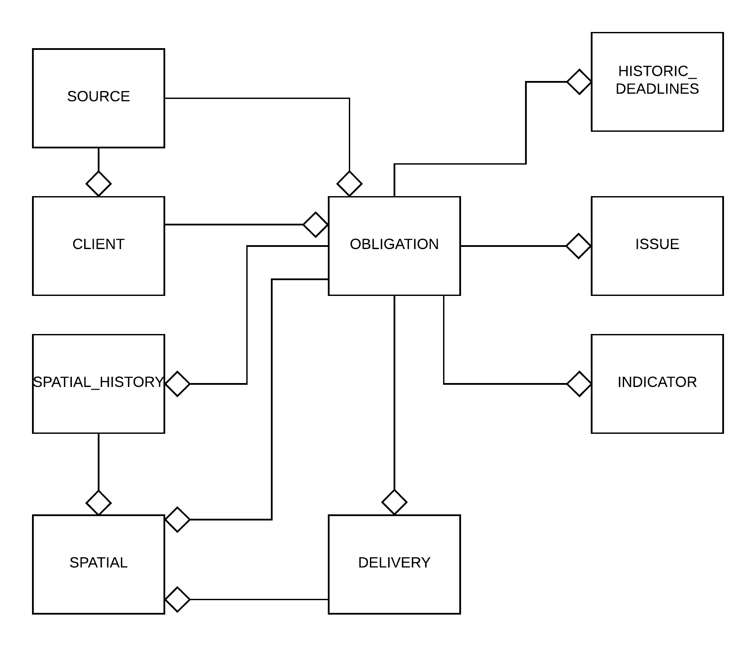
FULL DATABASE MODEL
(See the attached image)
*Working on the updates related to the last data model changes.

Best practices

Non-functional requirements fulfilment

The application has comprehensive unit and integration test coverage.

We will use the spring-test module for the production of unit-tests, and we will launch them automatically using JUnit and Jenkins.

We are setting up a deployment-server (within a continuous integration environment with Maven, Jenkins and SonarQube). This server will take the following actions:

- compile the code,
- launch tests,
- static code analysis (Chekstyle, PMD, Findbugs)
- deployment of the application

The application is delivered as a Docker image ready for deployment.

We will use Docker plugin for Maven (https://github.com/fabric8io/docker-maven-plugin)

The application is horizontally scalable.

Based on the application needs to be scaled and using the Docker image, we can set up a server cluster or Swarm in parallel.

The application does not log stack traces with printStackTrace() but instead logger.error(ex.getMessage(), ex)

We will use log4j to trace app issues in order to help the developers.

Default log configuration is developer friendly - i.e. print to stdout/stderr

We will use a configurable log output file and allow logging in external apps like Graylog.

Info-icons are positioned DIV - not old-tech popup (ref. #26905)

Use of jQuery / jQuery-UI at user interface level.

SECURITY:

- Using Spring security Framework, we will limit user’ access to the application URLs based on the defined roles. For example, URLs “admin/*” only for administrators, and URLS “user/*2 for all authenticated users. Its use also limits Cross-Site Scripting Vulnerabilities

- Using Spring-JDBC Framework we will limit SQL Injection vulnerabilities.

- We also suggest using AOP (aspect-oriented programming) in all common operations to all the layers, such as logging system ones (application logs).

- We propose to centralize exceptions behaviour in only one component ‘GlobalExceptionHandler’ using Spring Framework (@ControllerAdvice)

- Weekly code review to guarantee implementation security, showing the results in the security plan.

- At function level, we suggest to carry out impact analysis on security for each use case

Our development environment
Local development machines (for developers):

- S.O. Windows
- JDK 1.8
- Tomcat 8.5
- MySQL 5.7
- Eclipse Oxygen (IDE), with SonarLint plugin
- Git 2.15

Development Server (deployments and Continuous Integration - CI)

- S.O. Ubuntu Linux 16.04 LTS
- JDK 1.8
- Tomcat 8.5
- MySQL 5.7
- Maven 3.5.2
- Jenkins 2.73 LTS
- SonarQube 6.7 LTS
- Git 2.7.4
- Docker CE 17.06.x

The configuration of this server will be reviewed by our Security Manager in order to ensure the fulfilment of the security guidelines

We will use this server to run unit testing and continuous integration tasks before deploying the app package.

We will provide external access to the application deployed in this server.

We will be able to create Docker images to upload them to public repositories.

